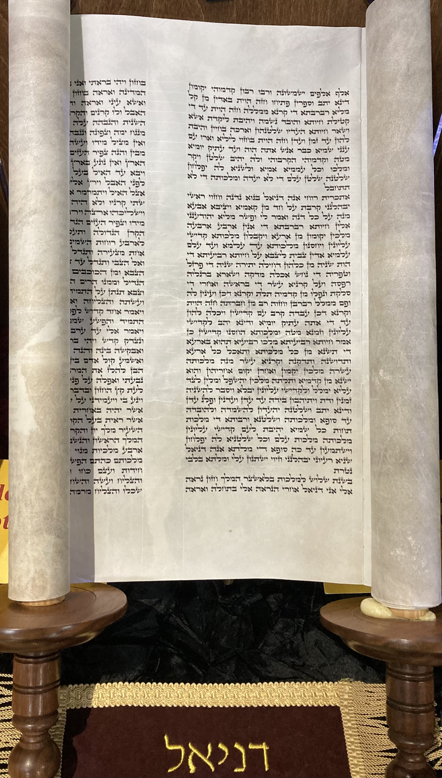
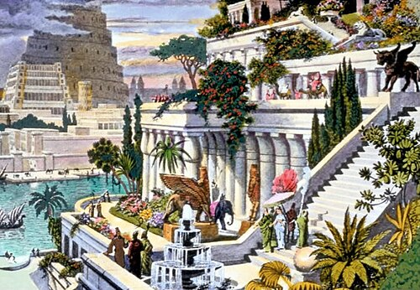
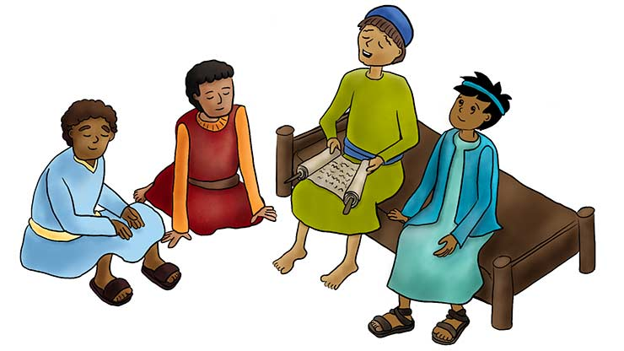

📖 The Book of Daniel – Chapter 1 (Full Bible Study)
Theme: Faithfulness to God in a Foreign Land
Key Message: God honors obedience, discipline, and faithfulness even under pressure.

📘 Overview of Book of Daniel – Chapter 1
Daniel chapter 1 introduces the historical setting of the Babylonian exile and highlights how God preserved and elevated faithful young men who chose obedience over compromise.

🕰️ Historical Context
- Time period: Around 605 BC
- Event: Babylon conquers Jerusalem
- King of Babylon: Nebuchadnezzar
- People taken captive: Young men from royal and noble families of Judah
This chapter sets the stage for the entire book by showing how God works even when His people are in captivity.

📜 Structure of Daniel Chapter 1
1️⃣ The Captivity of Judah (Daniel 1:1–2)
- Jerusalem is conquered
- Sacred items from God’s temple are taken to Babylon
- This fulfills earlier prophecies (see Jeremiah 25)
🔑 Lesson:
God’s sovereignty is not defeated by political loss or suffering. Even defeat is under His control.

2️⃣ The Selection of the Young Men (Daniel 1:3–7)
Four young men are introduced:
- Daniel
- Hananiah
- Mishael
- Azariah
Criteria for selection:
- Physically strong
- Intelligent
- Educated
- Without defect
Name changes (identity pressure):
- Daniel → Belteshazzar
- Hananiah → Shadrach
- Mishael → Meshach
- Azariah → Abednego
🔑 Lesson:
The world may try to change your identity, but God knows who you are.

3️⃣ Daniel’s Decision Not to Defile Himself (Daniel 1:8–14)
Daniel purposed in his heart not to eat the king’s food or drink his wine.
Why?
- Possibly violated Jewish dietary laws
- Food was likely offered to idols
- Symbol of dependence on Babylon instead of God
Daniel respectfully requests an alternative:
- Vegetables
- Water
- A 10-day test
🔑 Lesson:
True faith is both conviction-driven and respectful.

4️⃣ God Honors Faithfulness (Daniel 1:15–17)
After 10 days:
- They look healthier than others
- God gives them:
  - Knowledge
  - Wisdom
  - Understanding
- Daniel receives special insight into visions and dreams
🔑 Lesson:
Obedience brings God’s favor and spiritual insight.

5️⃣ Promotion and Excellence (Daniel 1:18–21)
- The king interviews them
- They are found 10 times better than all others
- Daniel serves through multiple reigns
🔑 Lesson:
Faithfulness to God produces excellence that even unbelievers recognize.

✝️ Major Spiritual Themes
🔹 God’s Sovereignty
Even in exile, God remains in control.
🔹 Holiness Without Isolation
Daniel lived in Babylon but did not become Babylonian in spirit.
🔹 Discipline and Self-Control
Spiritual strength begins with daily decisions.
🔹 God Rewards Obedience
Faithfulness leads to wisdom, favor, and influence.

👨‍👩‍👧‍👦 Application for Today
For Youth:
- Stand firm in your faith at school and among peers
- God honors those who choose obedience early in life
For Families:
- Teach children identity in God, not culture
- Discipline and faith bring generational blessing
For Leaders:
- Excellence flows from integrity
- God promotes faithful servants

📖 Key Memory Verse
Daniel 1:8
“But Daniel purposed in his heart that he would not defile himself…”

📝 Reflection Questions
- What pressures today challenge your faith?
- How can you honor God in daily decisions?
- What does “purpose in your heart” mean for you?

🙏 Closing Prayer
Lord, help us to remain faithful to You even when we are surrounded by pressure to compromise. Give us wisdom, discipline, and courage like Daniel. May our lives bring glory to Your name. Amen.

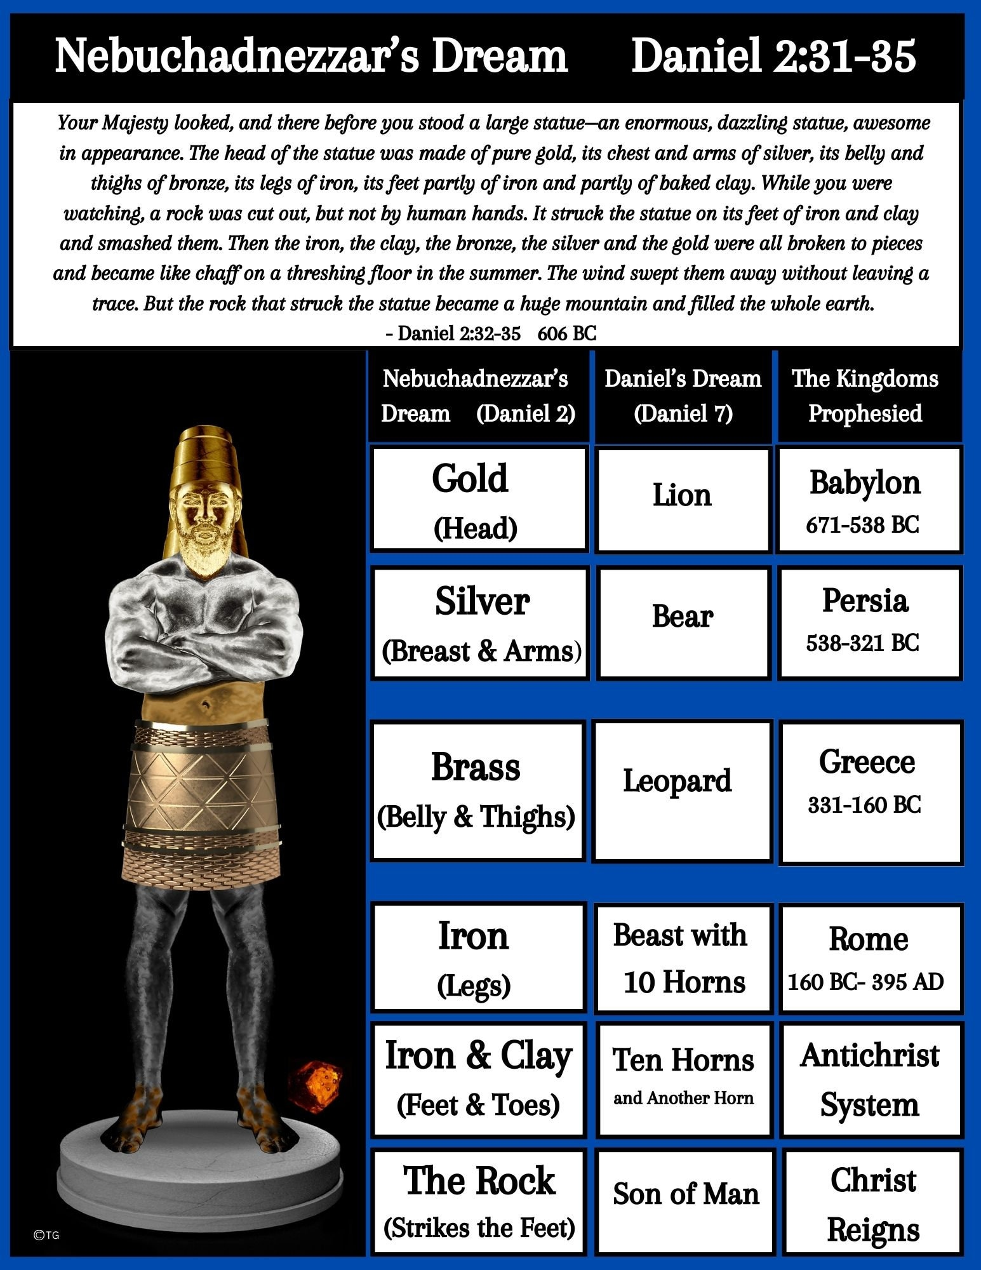
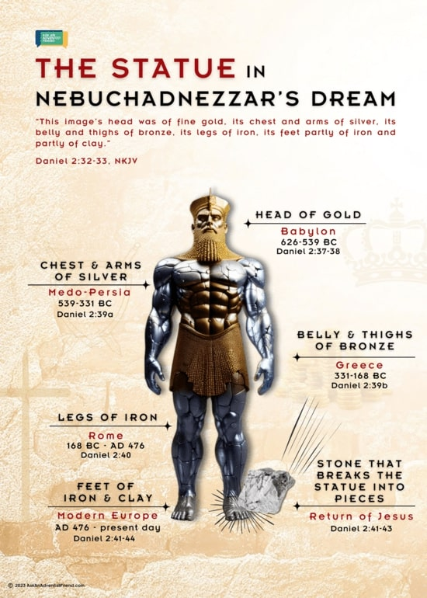
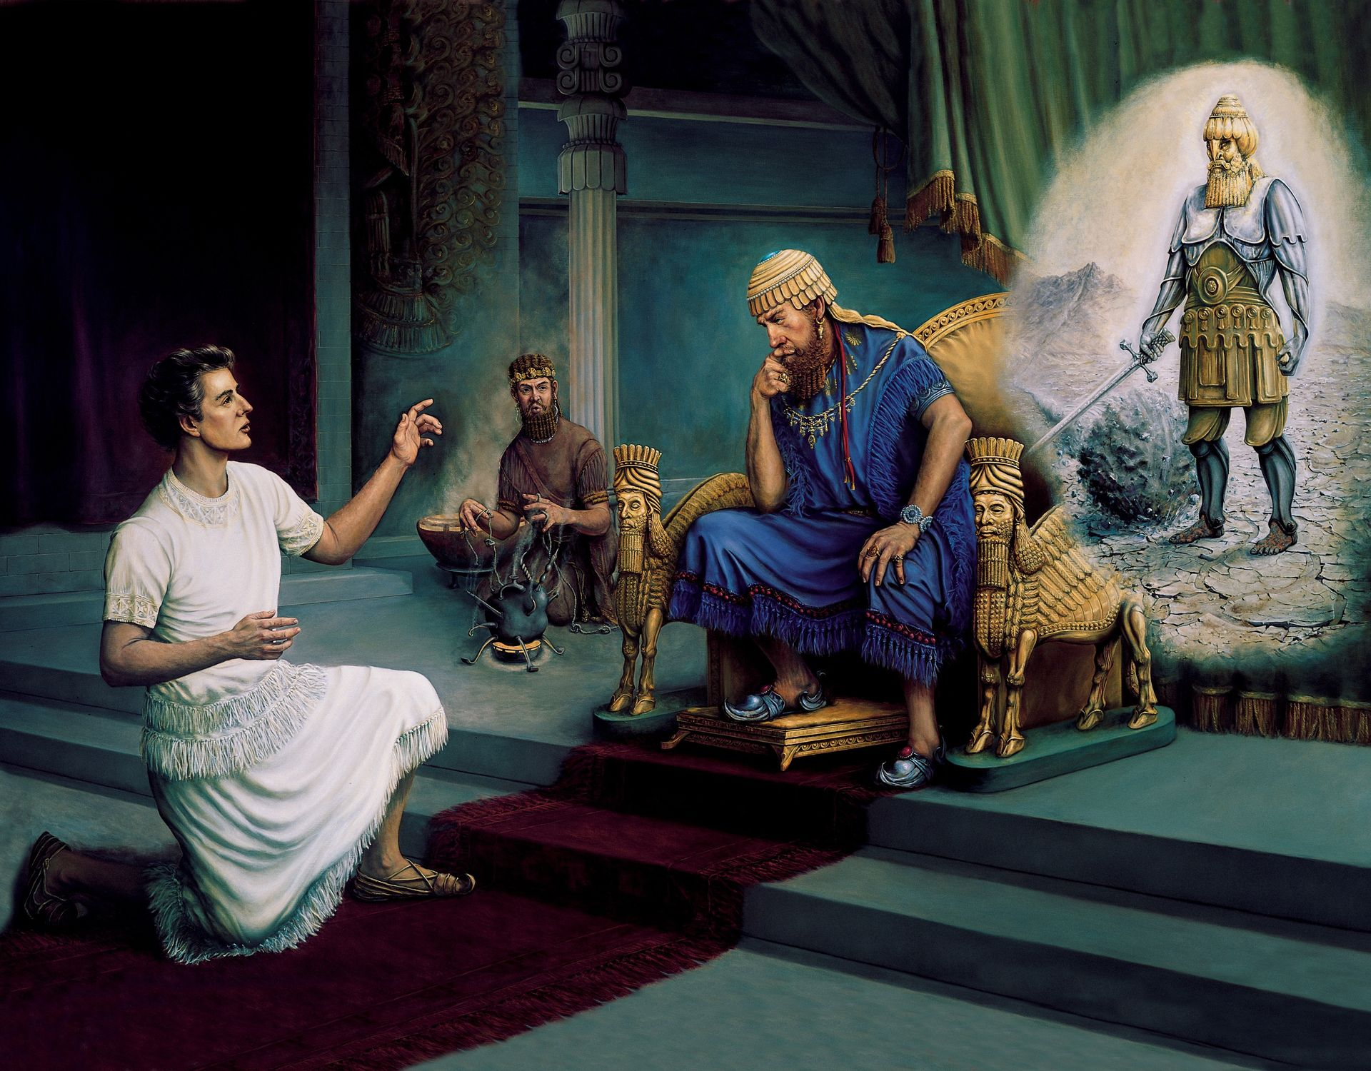
4
📖 The Book of Daniel – Chapter 2 (Full Bible Study)
Theme: God Reveals Mysteries and Rules Over Kingdoms
Key Message: God alone controls history, reveals truth, and establishes eternal dominion.

📘 Overview of Book of Daniel – Chapter 2
Daniel chapter 2 moves from personal faithfulness (chapter 1) to global prophecy. God reveals the future of world empires through a dream given to King Nebuchadnezzar and interpreted by Daniel.

🕰️ Historical Context
- Time period: Around 603 BC
- Setting: Babylon
- Ruler: King Nebuchadnezzar
- Crisis: The king has a dream but demands both the dream and its interpretation
This chapter introduces God’s prophetic timeline of world kingdoms.

📜 Structure of Daniel Chapter 2

1️⃣ The King’s Troubling Dream (Daniel 2:1–13)
- Nebuchadnezzar has a disturbing dream
- He demands the wise men:
  - Tell him the dream
  - Explain its meaning
- Failure means death
The wise men admit:
“No man can reveal this… except the gods.”
🔑 Lesson:
Human wisdom has limits. Only God knows hidden things.

2️⃣ Daniel’s Prayer and God’s Revelation (Daniel 2:14–23)
- Daniel responds with wisdom and calm
- He gathers his friends to pray
- God reveals the dream in a night vision
Daniel praises God:
- God changes times and seasons
- God removes and sets up kings
- God gives wisdom and knowledge
🔑 Lesson:
Prayer invites divine revelation. God responds to united faith.

3️⃣ Daniel Acknowledges God, Not Himself (Daniel 2:24–30)
Daniel makes it clear:
- Wisdom comes from God
- Interpretation is not by human power
- Revelation is for God’s glory
🔑 Lesson:
True servants of God always point people to Him, not themselves.

4️⃣ The Dream of the Great Statue (Daniel 2:31–35)
Nebuchadnezzar sees a massive statue:
Part of Statue | Material
Head | Gold
Chest & Arms | Silver
Belly & Thighs | Bronze
Legs | Iron
Feet | Iron mixed with clay
Then:
- A stone cut without hands strikes the statue
- The statue collapses
- The stone becomes a great mountain filling the earth
🔑 Lesson:
Earthly kingdoms are temporary. God’s kingdom is eternal.

5️⃣ Interpretation of the Dream (Daniel 2:36–45)
🌍 The World Empires
Statue Part | Kingdom
Gold Head | Babylon
Silver Chest | Medo-Persia
Bronze Belly | Greece
Iron Legs | Rome
Iron & Clay Feet | Divided kingdoms
🪨 The Stone
- Represents God’s Kingdom
- Not made by human hands
- Will destroy all earthly kingdoms
- Will stand forever
🔑 Lesson:
Jesus Christ is the cornerstone of God’s eternal kingdom.

6️⃣ The King’s Response and Daniel’s Promotion (Daniel 2:46–49)
- Nebuchadnezzar acknowledges Daniel’s God
- Daniel is promoted
- His friends receive leadership roles
🔑 Lesson:
God honors faithfulness with influence and responsibility.

✝️ Major Spiritual Themes
🔹 God Reveals Mysteries
God discloses truth to those who seek Him humbly.
🔹 God Controls History
Nations rise and fall by God’s command.
🔹 Prayer Precedes Power
Victory begins in prayer, not position.
🔹 The Eternal Kingdom
Human power fades, but God’s kingdom lasts forever.

👨‍👩‍👧‍👦 Application for Today
For Believers:
- Trust God even when situations seem impossible
- Seek God before acting
For Youth:
- Prayer brings wisdom beyond education
- God can use young people to influence nations
For Leaders:
- Authority is given by God
- Leadership must remain humble and accountable

📖 Key Memory Verse
Daniel 2:20–21
“Blessed be the name of God forever and ever: for wisdom and might are his:
And he changeth the times and the seasons: he removeth kings, and setteth up kings…”

📝 Reflection Questions
- What impossible situation do you need to bring to God in prayer?
- Where might you be relying on human wisdom instead of God?
- How does the eternal kingdom shape your priorities?

🙏 Closing Prayer
Sovereign God, You alone reveal mysteries and rule over all kingdoms. Teach us to trust You, seek You in prayer, and live for Your eternal kingdom. Amen.

