

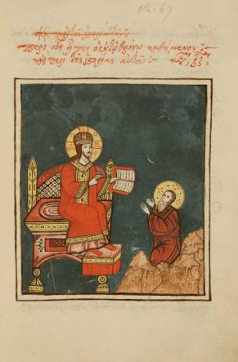
4
📖 The Book of Daniel – Chapter 12 (Full Bible Study)
Theme: Final Deliverance, Resurrection, and Everlasting Reward
Key Message: God brings history to its appointed end with resurrection, judgment, and eternal life for the faithful.

📘 Overview of Book of Daniel – Chapter 12
Daniel chapter 12 concludes the book with hope beyond suffering. After revealing persecution and conflict (chapters 10–11), God promises final deliverance, resurrection of the dead, and everlasting rewards for those who remain faithful.

🕰️ Historical & Prophetic Context
- Continuation: Directly follows the vision of chapter 11
- Focus: “The time of the end”
- Audience: God’s people facing distress and persecution
This chapter assures believers that history does not end in chaos—but in redemption.

📜 Structure of Daniel Chapter 12

1️⃣ Michael and the Time of Great Distress (Daniel 12:1)
- Michael stands up
- A time of unprecedented trouble occurs
- God’s people whose names are written in the book are delivered
🔑 Lesson:
God actively protects His people in the darkest times.

2️⃣ The Resurrection of the Dead (Daniel 12:2–3)
This is one of the clearest Old Testament teachings on resurrection:
- Some rise to everlasting life
- Some rise to shame and everlasting contempt
- The wise shine like stars forever
🔑 Lesson:
Life continues beyond death—choices in this life have eternal consequences.

3️⃣ The Book Is Sealed Until the End (Daniel 12:4)
- Daniel is told to seal the book
- Knowledge will increase
- Many will search for understanding
🔑 Lesson:
God reveals truth progressively—clarity comes in His time.

4️⃣ How Long Will It Be? (Daniel 12:5–7)
- Two angels ask about the duration
- A heavenly figure swears by God:
“A time, times, and half a time”
- When persecution ends, deliverance follows
🔑 Lesson:
Suffering has a divine time limit.

5️⃣ Understanding Comes to the Wise (Daniel 12:8–10)
- Daniel does not fully understand
- The wicked remain blind
- The wise gain understanding
🔑 Lesson:
Spiritual insight belongs to those who walk faithfully with God.

6️⃣ The Final Time Periods (Daniel 12:11–12)
- 1,290 days
- 1,335 days
- A blessing for those who endure patiently
🔑 Lesson:
Faithfulness and perseverance lead to blessing.

7️⃣ Daniel’s Peaceful Conclusion (Daniel 12:13)
God tells Daniel:
- Go your way
- Rest
- You will rise to receive your inheritance at the end
🔑 Lesson:
God rewards faithfulness—even after a lifetime of service.

✝️ Major Spiritual Themes
🌅 Resurrection Hope
Death is not the end for God’s people.
🌅 Final Judgment
God judges righteously and eternally.
🌅 Endurance of the Saints
Faithfulness through trials leads to glory.
🌅 Eternal Reward
The wise shine forever in God’s kingdom.

👨‍👩‍👧‍👦 Application for Today
For Believers:
- Live with resurrection hope
- Remain faithful under pressure
For the Church:
- Teach eternal perspective
- Encourage perseverance
For Families:
- Speak about eternal life and hope
- Model faithful endurance
For Youth:
- Your faith today shapes your eternity
- God sees and rewards faithfulness

📖 Key Memory Verse
Daniel 12:3
“They that be wise shall shine as the brightness of the firmament; and they that turn many to righteousness as the stars for ever and ever.”

📝 Reflection Questions
- How does the promise of resurrection change how you live now?
- What does it mean to be among “the wise”?
- How can believers endure faithfully in difficult times?

🙏 Closing Prayer
Eternal God, thank You for the hope of resurrection and everlasting life. Strengthen us to remain faithful, wise, and steadfast until the end. May our lives shine for Your glory now and forever. Amen.

